NAME: Rishi Ponkya
PROJECT: Implementing Security into a Secure Password Manager Application
INSTIUTION: First Quadrant Labs
SUBMISSION DATE: 28 October 2026
PROJECT TITLE: Security Architecture Document – Including diagrams and security control mappings.

1. Security Architecture Document
The design is zero-knowledge: clients encrypt and decrypt everything, the server stores and serves ciphertext only, and every access path is authenticated with a second factor, restricted by role and logged. The platform is the Bit warden clients with a self-hosted Vault warden server, chosen because the brief requires free and open-source software.

1.1 Architecture overview
Users reach the server only through a TLS reverse proxy. Behind it, the Vault warden server handles authentication, role checks and event logging, and keeps only encrypted data. Backups and logs leave the server through two separate, one-way paths.

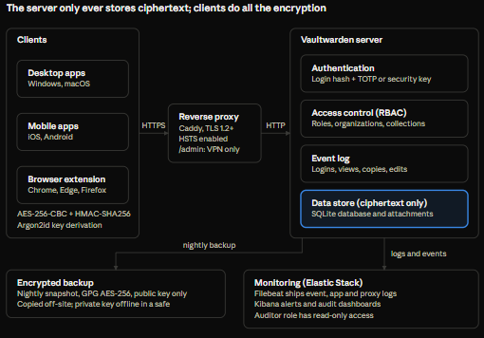

[embed: node/9336f5fe-fe72]
Clients encrypt before anything is sent. The proxy, server and database only handle ciphertext, and backups and logs leave on separate one-way paths.
1.2 Components
Component | Technology
Desktop clients | Bit warden desktop (Windows, macOS)
Mobile clients | Bit warden iOS and Android apps
Browser extensions | Bit warden extension (Chrome, Edge, Firefox, Safari)
Reverse proxy | Caddy
Application server | Vault warden (Docker)
Data store | SQLite database and file folders
Backup job | sqlite3, GPG, rclone
Monitoring | File beat, Elasticsearch, Kibana

1.3 Authentication flow
- The user enters email and master password. The client derives the master key with Argon2id and a login hash, all on the device.
- The client sends only the login hash over TLS. The server checks it (re-hashing it with its own salt) and applies the rate limit.
- The server asks for the second factor, and the user supplies a TOTP code or a security-key touch.
- The server returns a short-lived session token plus the user's encrypted account key and organization keys.
- The client decrypts those keys in memory, decrypts vault items on demand, and locks again after 15 minutes of inactivity.

1.4 Trust boundaries and data flows

- Never leaves the device: the master password, master key and decrypted account key.
- Crosses to the server: the login hash, encrypted vault items, encrypted keys, and request metadata (IP address, device type).
- Crosses to backup storage: a GPG-encrypted archive that only an offline private key can open.
- Crosses to the log host: event IDs, user IDs and IP addresses, but no passwords and no item names.
- Admin interface: reachable only from the management VPN range.

1.5 Platform selection

Platform | Central server | RBAC and sharing | Audit logging | Fit for this brief
Bitwarden clients with Vaultwarden server (selected) | Yes | Roles, collections, end-to-end encrypted sharing | Organization event log | Meets every objective with free, open-source software
KeePassXC | No (a database file) | None built in; sharing means syncing the file | None | Good for individuals, not for managed teams
Passbolt | Yes | Roles, groups, OpenPGP sharing | Action logs are in the paid Pro edition (check the current edition table) | Strong runner-up; the free edition lacks audit logging
Padloc | Yes | Organizations and vaults | Limited | Smaller ecosystem; check release activity before relying on it

Vault warden is community-maintained and has not had Bit warden’s own security audit, so keep it patched.

1.6 Security control mapping
Control objective | Control implemented | Document | ISO/IEC 27001:2022 Annex A | NIST SP 800-53
Confidentiality of stored credentials | Client-side AES-256 encryption, zero-knowledge server | 2 | A.8.24 | SC-28
Resistance to master password guessing | Argon2id (64 MiB, 3 iterations, 4 lanes), OWASP-aligned | 2 | A.8.24 | IA-5
Tamper detection | HMAC-SHA256 on every item, backup checksums | 2, 4 | A.8.24 | SI-7
Strong authentication | Mandatory TOTP or FIDO2, login rate limiting, fail2ban | 3 | A.8.5 | IA-2(1)
Least privilege | Roles, collection permissions, single-organization policy | 3 | A.5.15, A.8.2 | AC-6
Protection in transit | TLS 1.2+ with HSTS | 1, 5 | A.8.24 | SC-8
Availability and recovery | Encrypted nightly backup, monthly restore drill | 4 | A.8.13 | CP-9
Secure sharing | Per-organization keys, collection-based access | 6 | A.5.14 | SC-12
Logging and monitoring | Event log, Elastic Stack alerts | 7 | A.8.15, A.8.16 | AU-2, AU-6
User awareness | Onboarding session, handbook, annual refresher | 8 | A.6.3 | AT-2

1.7 Threats and mitigations

Threat | Mitigation
Attacker steals the server database | Data is ciphertext, and Argon2id makes offline guessing of master passwords slow
Phishing for the master password | MFA, host-matched autofill (no fill on a fake site), training
Malicious or careless administrator | No plaintext access, least-privilege roles, every change logged and reviewed
Stolen or lost device | 15-minute lock, master password needed after restart, full-disk encryption
Stolen backup | Archive encrypted to a public key whose private half is offline
Password guessing against the login | Rate limiting, fail2ban, alerts on repeated failures
Outdated or tampered software | Image pinned by digest, monthly patch window, staging test before production

